Dropbox Installation Instructions for Mac

- Click the following link: https://www.dropbox.com/downloading?os=mac.

- Your Web browser should automatically begin downloading Dropbox 1.0.10.dmg. Follow the instructions below to install the software once it has been downloaded.

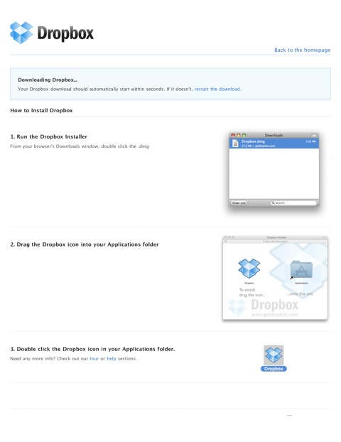

- After launching Dropbox for the first time, you will be asked to select whether you are a new or existing user. Select I don't have a Dropbox account, then click Next.

- Enter your name, your selu.edu E-mail address, a password that you will remember, and a short, descriptive name for your computer (e.g. Charles's MacBook), then click Next.

- Select 2GB Free, then click Next.

- Accept the remaining default selections—taking or skipping the tour as desired. (Note: if you would prefer to place your Dropbox folder somewhere other than the default location, click I want to choose where to put my Dropbox folder. Growl notifications are also optional, but recommended; these will alert you when changes are made to Dropbox files and folders.)

- You should receive an E-mail invitation similar to the one below:

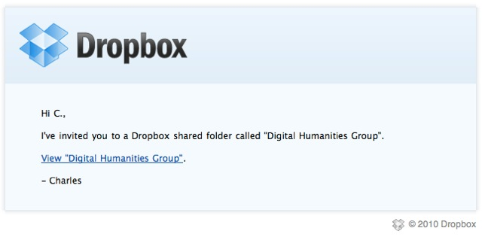

Follow the link in the E-mail to add the Digital Humanities Group shared folder to your Dropbox.

IMPORTANT: You should avoid dragging and dropping shared files or folders from Dropbox to your Mac, as doing so will cause them to be removed from Dropbox.

Dropbox Installation Instructions for Windows

- Click the following link: https://www.dropbox.com/downloading?os=win.

- Your Web browser should automatically begin downloading Dropbox 1.0.10.exe. Follow the instructions below to install the software once it has been downloaded.

- You will be asked to select whether you are a new or existing user. Select I don't have a Dropbox account, then click Next.

- Enter your name, your selu.edu E-mail address, a password that you will remember, and a short, descriptive name for your computer (e.g. David's PC), then click Next.

- Select 2GB Free, then click Next.

- Accept the remaining default selections—taking or skipping the tour as desired. (Note: if you would prefer to place your Dropbox folder somewhere other than the default location, click I want to choose where to put my Dropbox folder.)
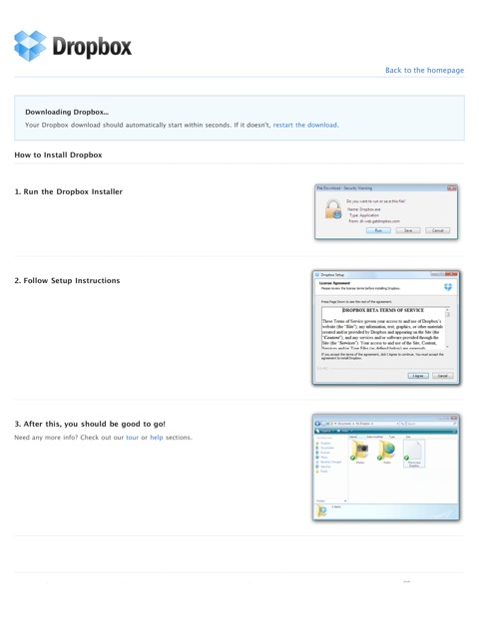

- You should receive an E-mail invitation similar to the one below:

Follow the link in the E-mail to add the Digital Humanities Group shared folder to your Dropbox.

IMPORTANT: You should avoid dragging and dropping shared files or folders from Dropbox to your PC, as doing so will cause them to be removed from Dropbox.

Notes

You can install Dropbox on as few or as many computers as you wish, as well as on your iPhone/iPod Touch/iPad, Android, and/or BlackBerry mobile device, using your newly-created, free Dropbox account.

