Finding and Replacing Text in Multiple Files with Oxygen XML Editor

You can use Oxygen XML Editor's Find/Replace in Files feature to find and/or replace text in multiple files. This document illustrates two ways to replace found text. In practice, it's usually a good idea to start with Scenario 1, then move on to Scenario 2.

Scenario 1
You know exactly what text you want to replace and exactly what you want to replace that text with.

Let's say that you've just discovered that Yarrow Valley is a geographical feature—not a place, as you've been encoding it. You want to replace every instance of <placeName corresp="#YARROWVALLEY">Yarrow Valley</placeName> with <geogName corresp="#YARROWVALLEY">Yarrow Valley</geogName>.

- Click Find, then Find/Replace in Files….

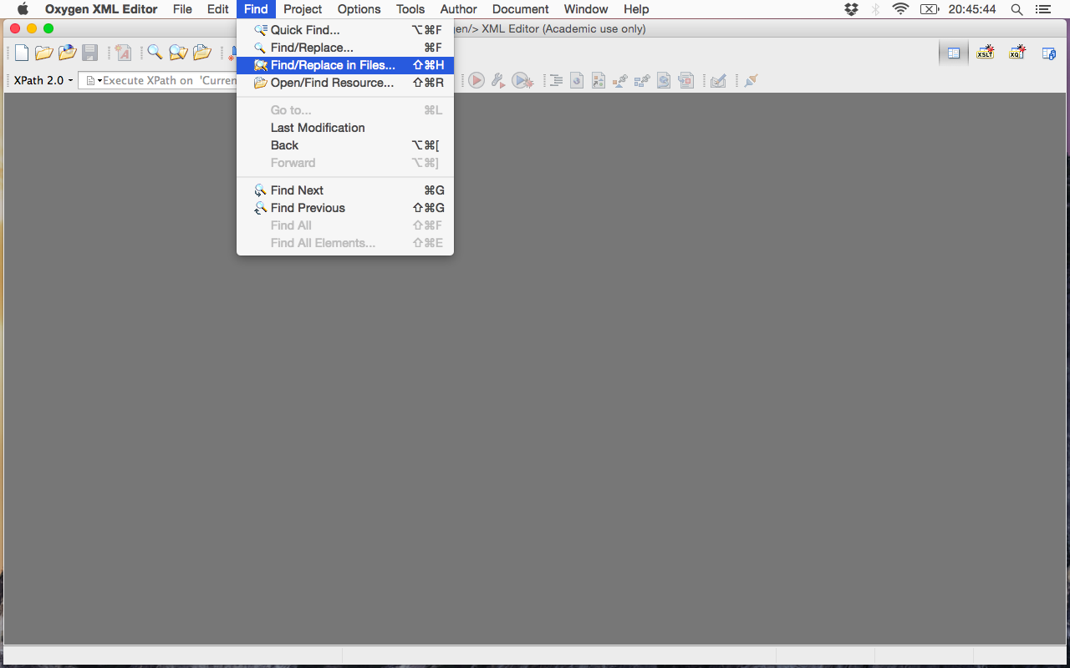

- Beneath Text to find, enter the text that you want to replace. Beneath Replace with, enter what you want to replace that text with. Be sure to enter both exactly.

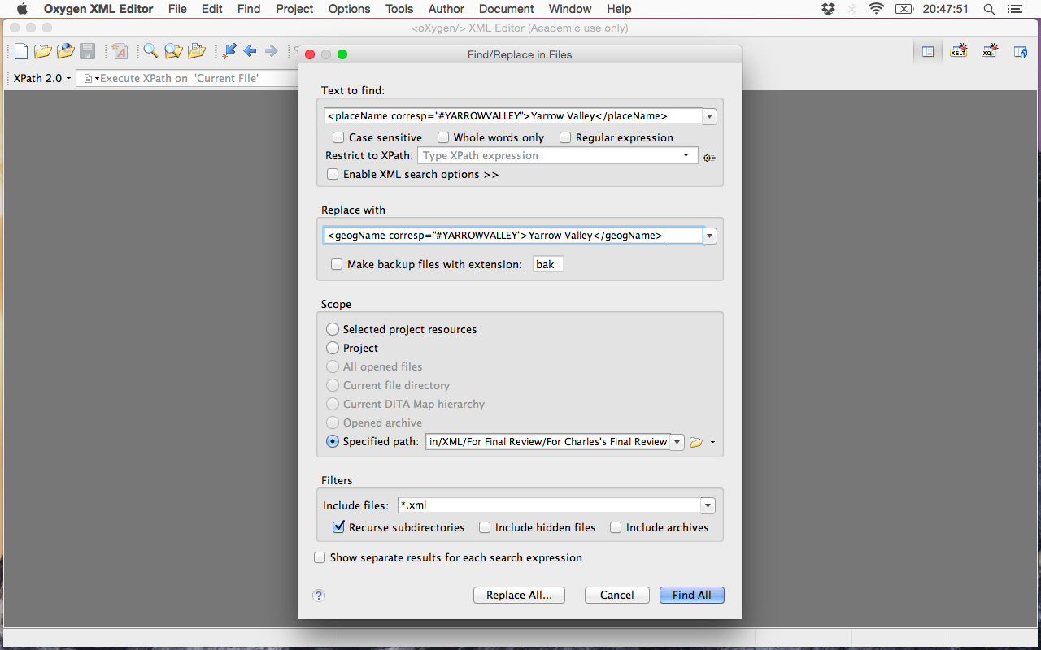
- Beneath Scope, click Specified path, then click the folder icon to the right.

- The Choose window will appear. Browse to the folder in which your files are located, then click Choose.

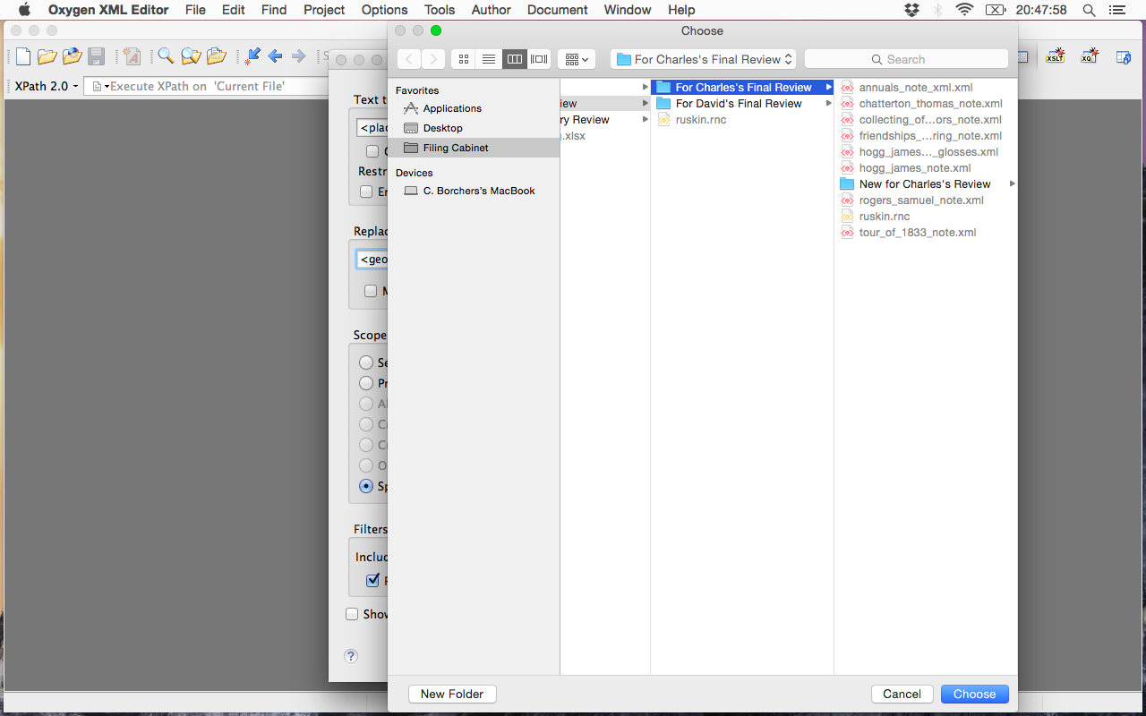
- Beneath Filters, enter *.xml beside Include files and check Recurse subdirectories. Double-check your entries and selections, then click Replace All….

- The Replace All dialog box will appear. Click Replace All.

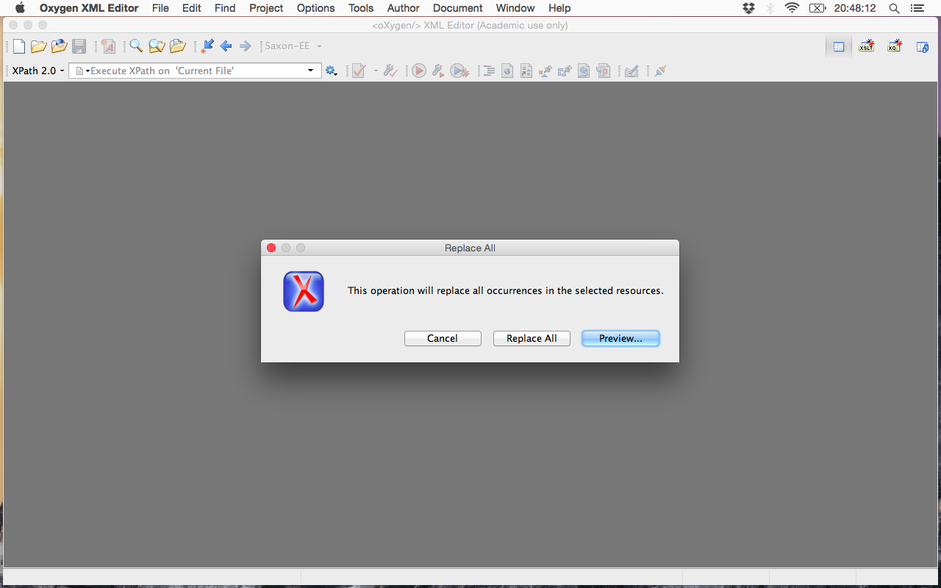
- The Replace Result dialog box will appear, indicating how many files were scanned and how many replacements were made.

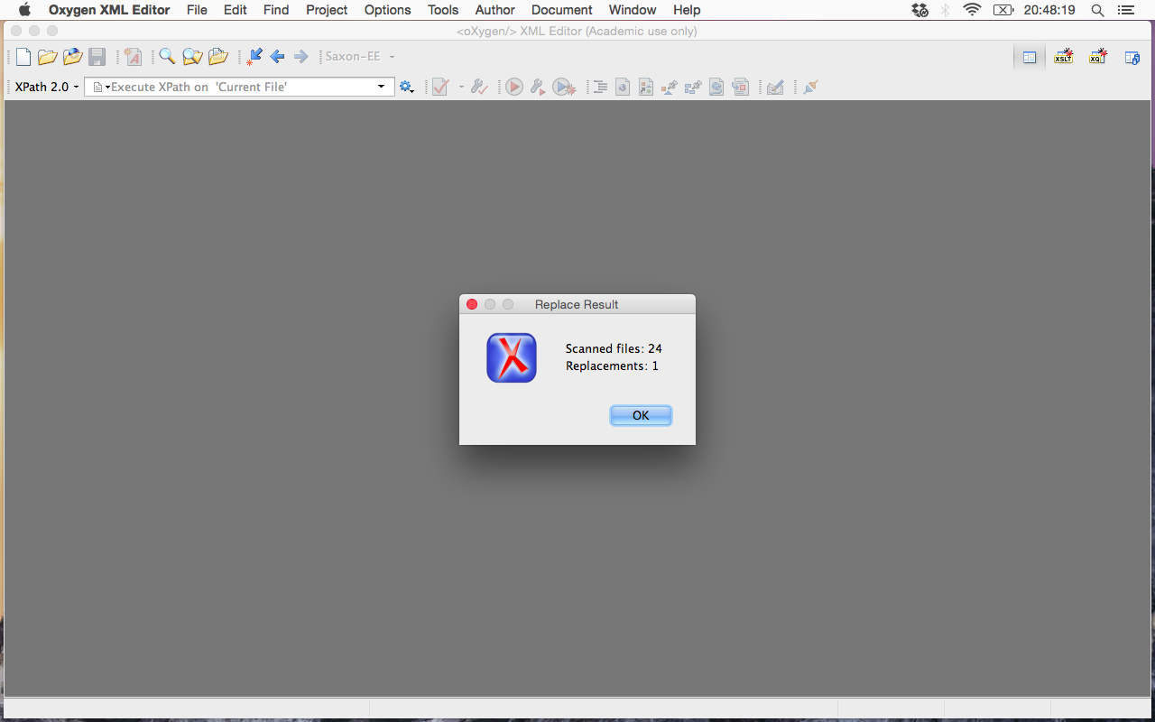

At this point, you might be done. Or you might not.

Scenario 2
Variations exist in the text that you want to replace.

Let's say that you've just discovered that Yarrow Valley is a geographical feature—not a place, as you've been encoding it—only this time, you also know that Yarrow Valley appears as "Yarrow Valley," "Yarrow," and, even, the "Valley" in your files. Simply replacing every instance of <placeName corresp="#YARROWVALLEY">Yarrow Valley</placeName> with <geogName corresp="#YARROWVALLEY">Yarrow Valley</geogName> won't work. You could try replacing Yarrow Valley beneath Text to find and Replace with with its variations—and this might work. But in instances where you might have multiple variations and/or not know them all, Scenario 2 is your best bet.

- Click Find, then Find/Replace in Files….

- Beneath Text to find, enter the text you know needs to be replaced (e.g. <placeName corresp="#YARROWVALLEY">). Again Be sure to enter both exactly. And, this time, beneath Replace With, enter nothing (or make sure that the space is blank).

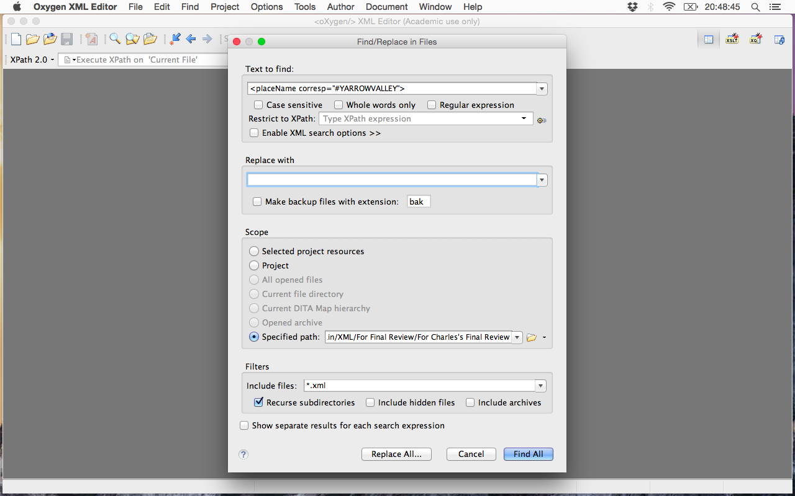

- Beneath Scope, click Specified path, then click the folder icon to the right.

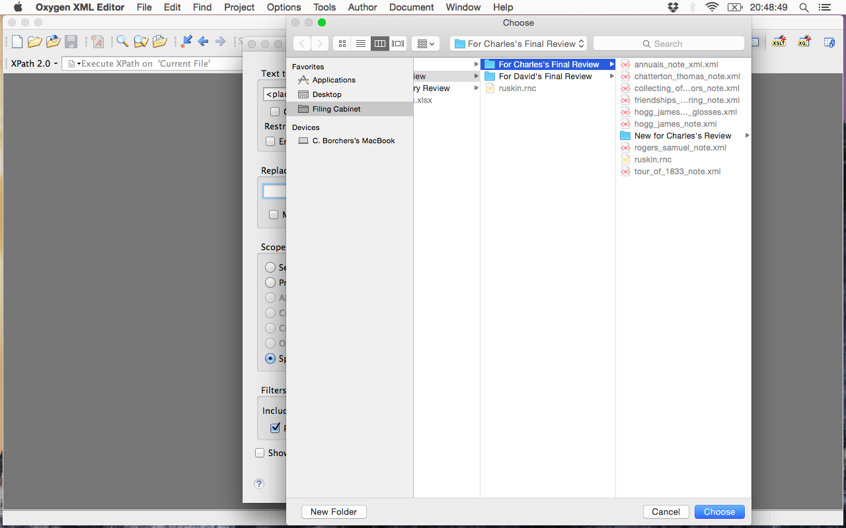
- The Choose window will appear. Browse to the folder in which your files are located, then click Choose.

- Beneath Filters, enter *.xml beside Include files and check Recurse subdirectories. Double-check your entries and selections, then click Find All.

- Oxygen XML Editor will display a window similar to the following. Double-click the first instance of found text at the bottom of the window.

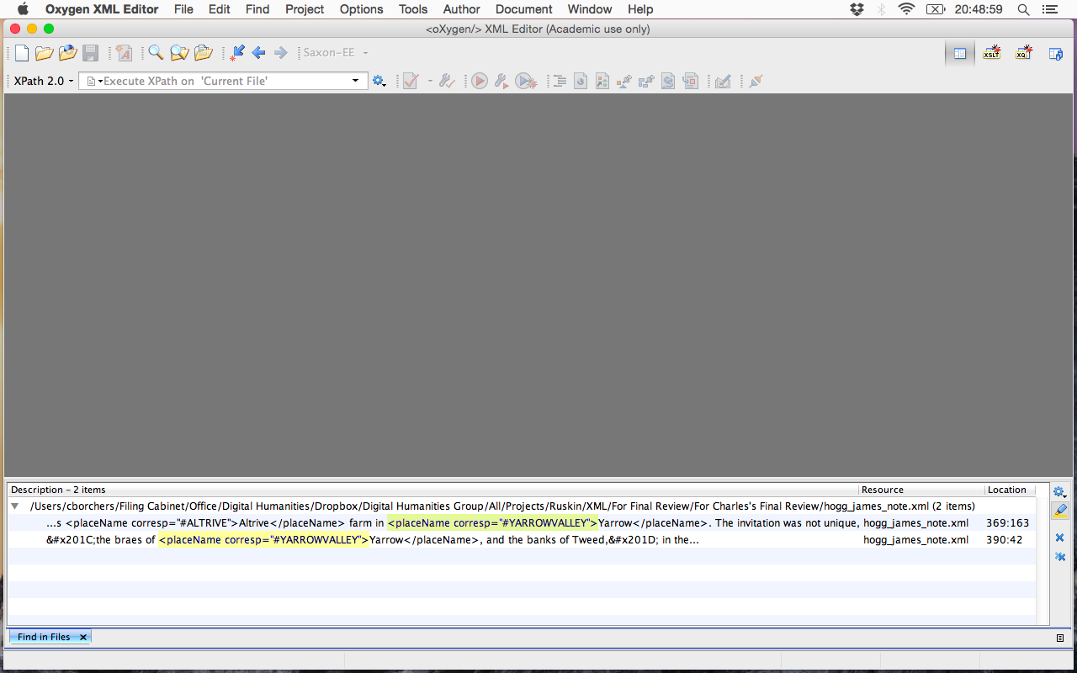

- The XML file containing the found text will open, and your cursor should be placed at the first instance of found text in the file. Edit the text in the file (e.g. changing persName to geogName in the start tag). Note: editing a start tag in a file will cause the corresponding end tag to be updated as well; end tags are NOT updated when only start tags are replaced using Replace All…—resulting in invalid markup.

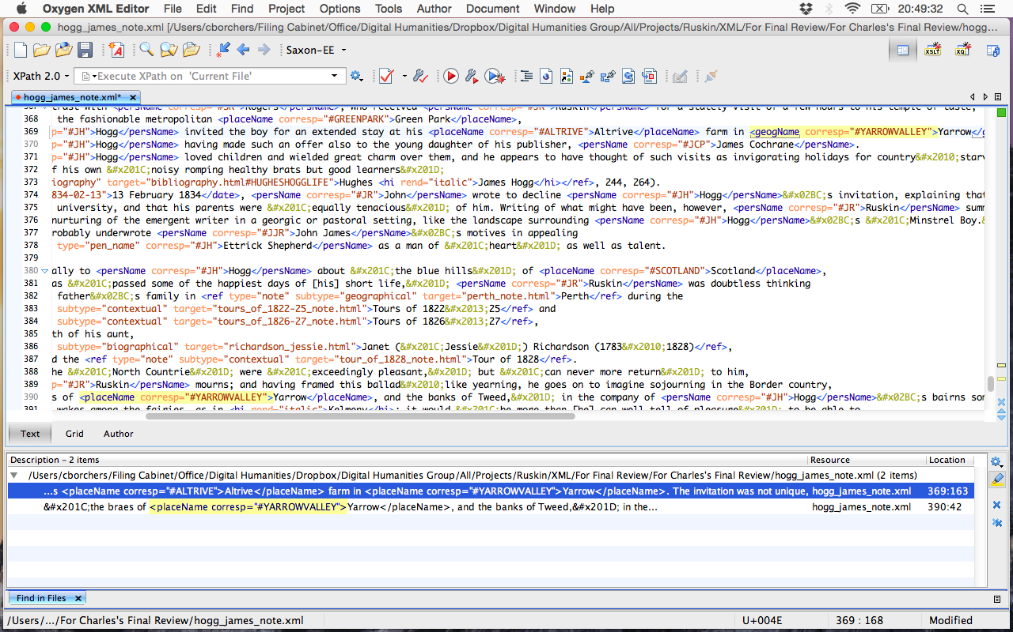
- At the bottom of the window, click on the next instance of found text. Your cursor should be placed at this instance in the file. Edit the text in the file. Repeat these steps for each instance of found text in the file, then save the file.

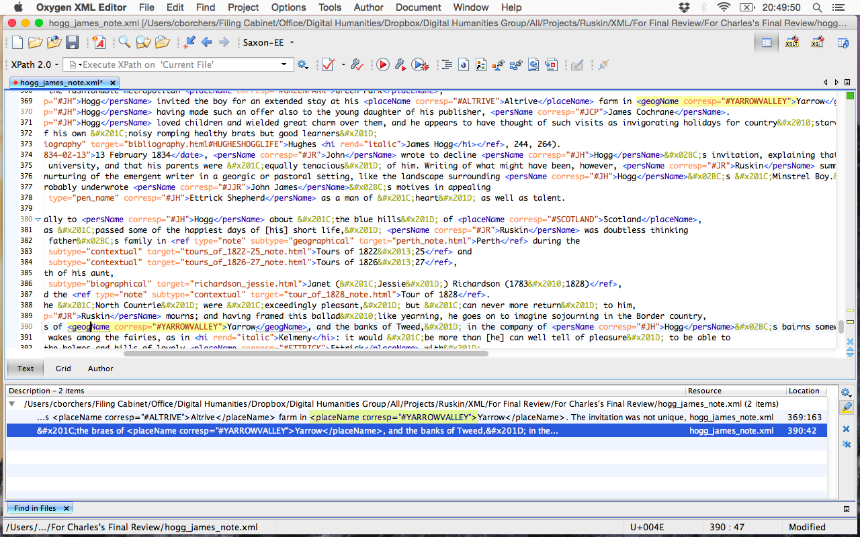

Note: found text at the bottom of the window is nested beneath the file(s) in which it was found. In the following example, at least three files exist in which <ref type="gloss" has been found. Double-clicking found text in the second or third file will open that file.

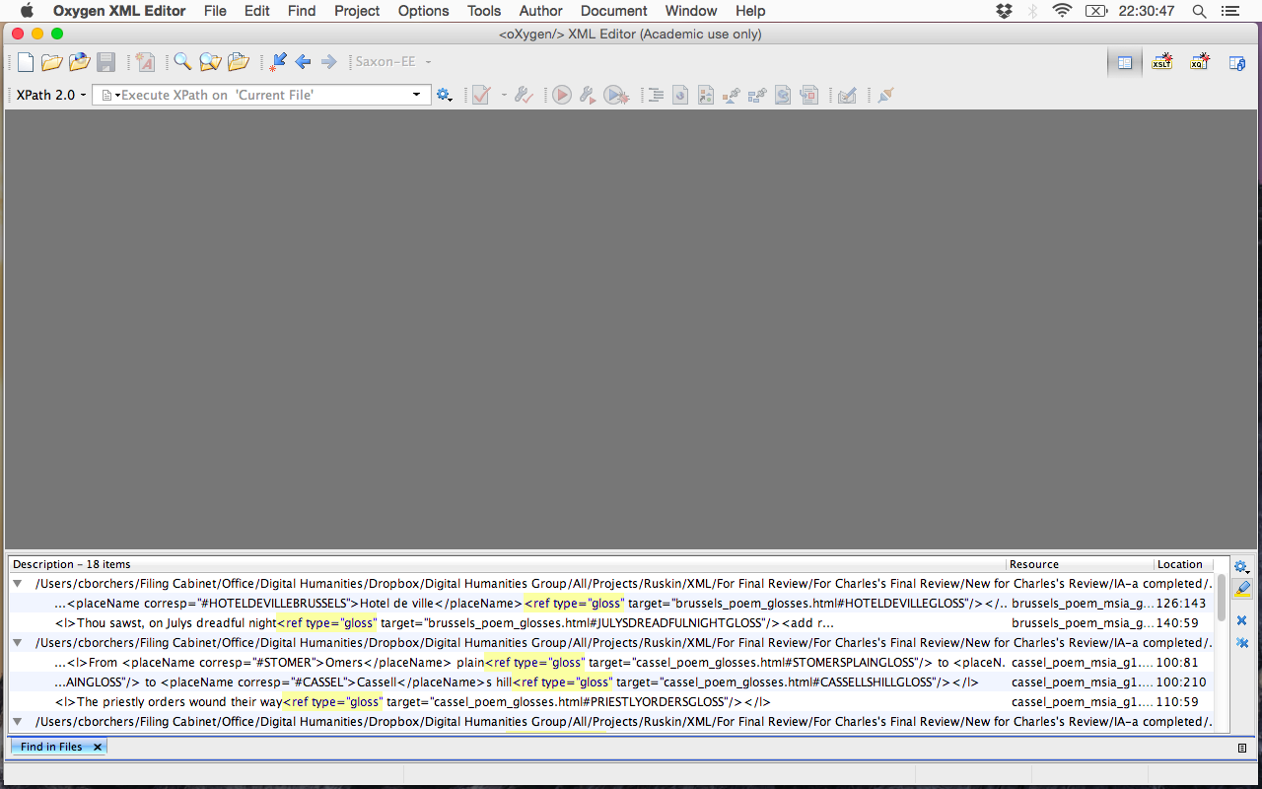

Tips

When performing updates of XML IDs, it’s usually a good idea to run a Find/Replace in Files on the XML ID both with and without the #—to catch any instances in which the # may have been accidentally left out during encoding.

