Sharing the Digital Humanities Group Folder

- Browse to http://www.dropbox.com—then click Sign in.

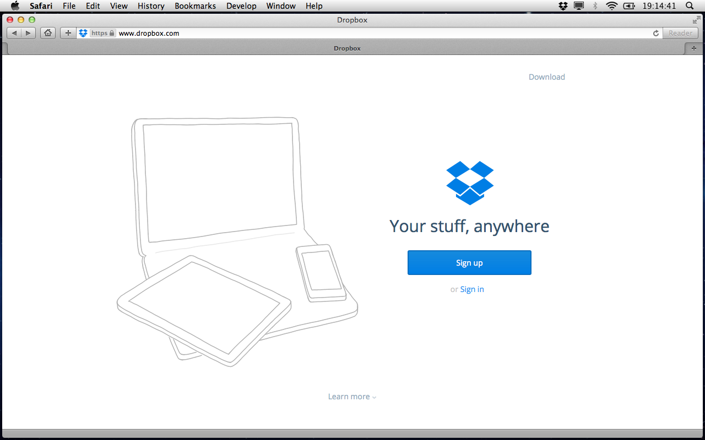
- In the Sign in box, enter digitalhumanities@selu.edu and the account's password (you can uncheck Remember me)—then click Sign in.

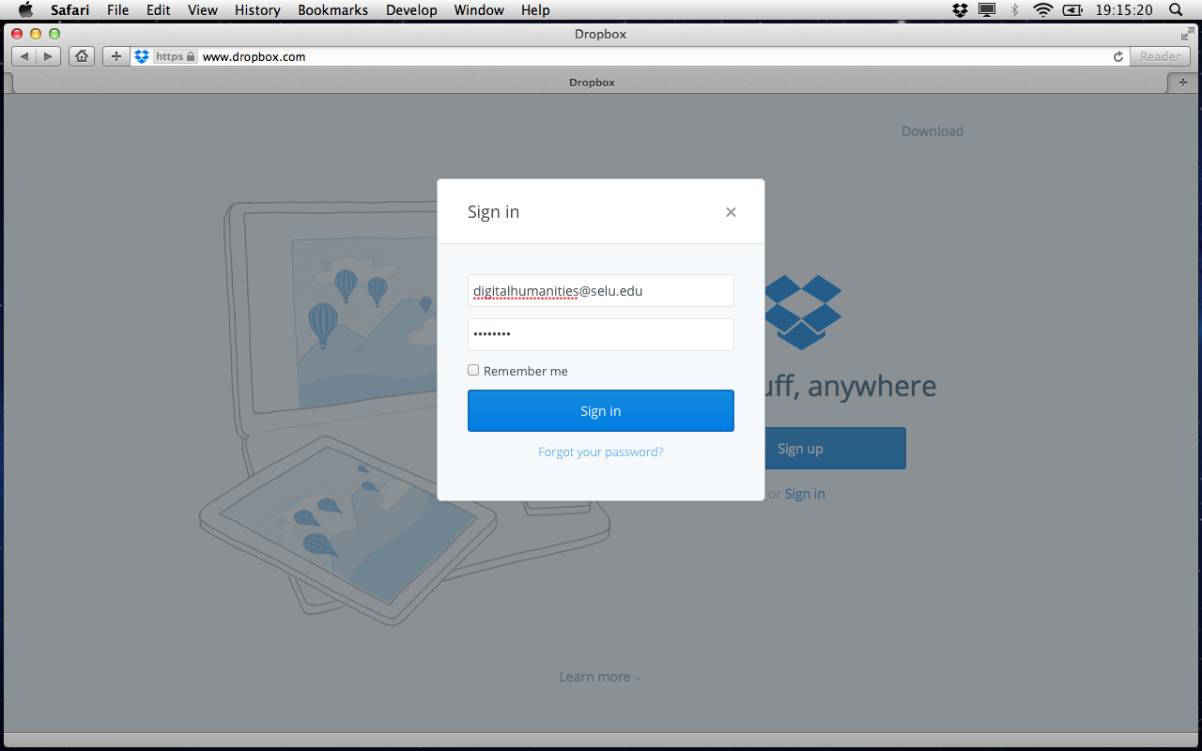
- On the Files page, click Sharing on the left.

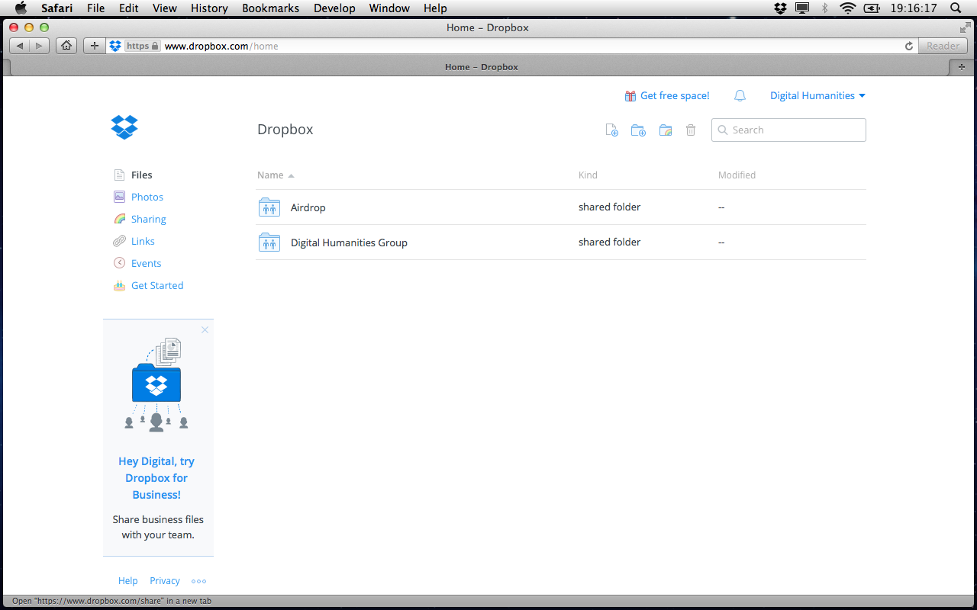
- On the Sharing page, to the right of Digital Humanities Group, click Options.

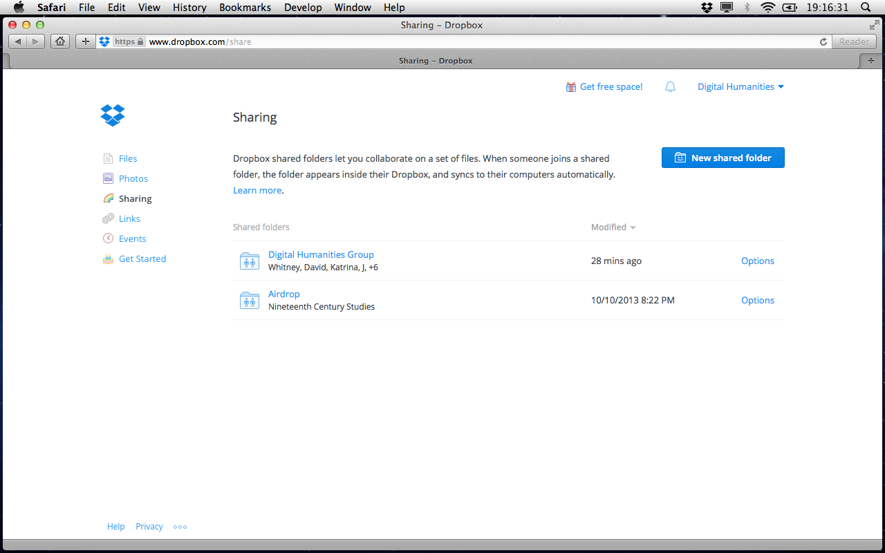
- In the Shared folder options for 'Digital Humanities Group' box, in the space to the left of Import contacts, enter the email address of the individual with whom you wish to share the Digital Humanities Group folder—then click Send invites.

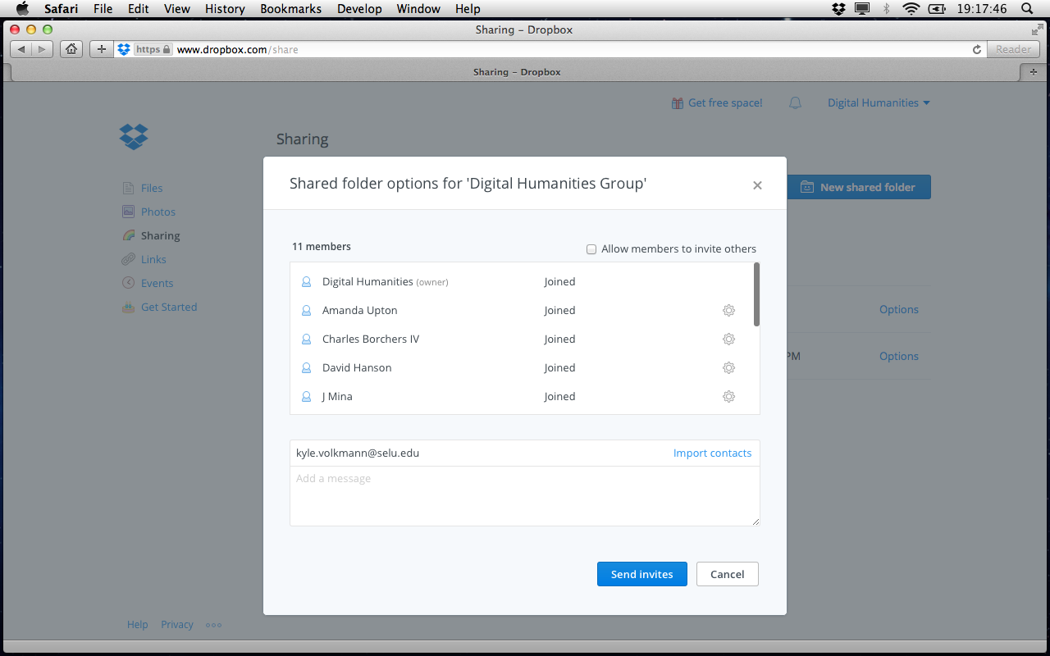
- Check the top of the Sharing page, to which you should be returned, for "Invited successfully."

